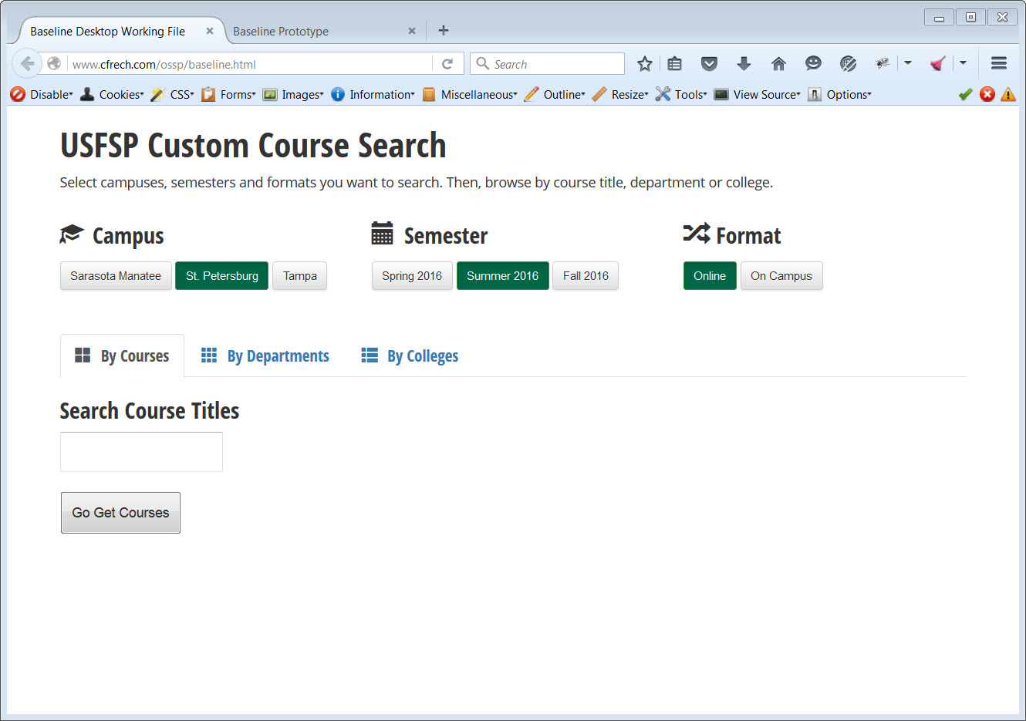

Figure 1. First prototype developed based on survey results from students. This early functional version was tested by students.

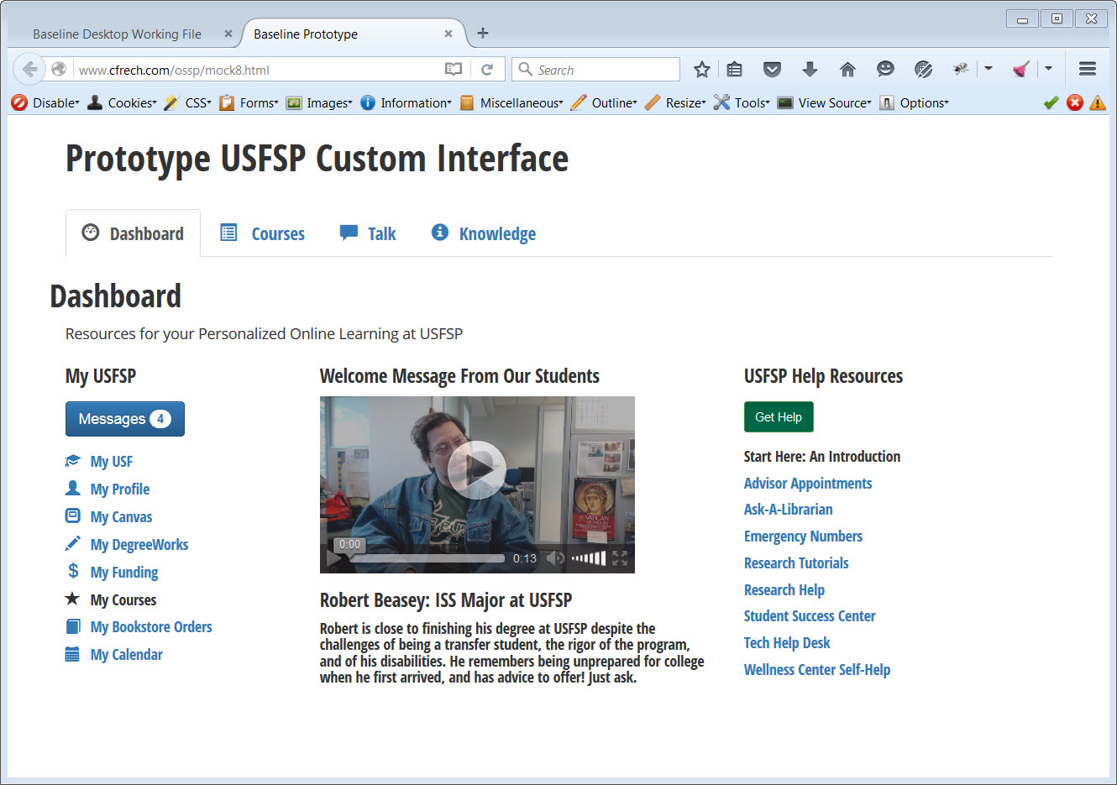

Figure 2. Landing page of second prototype, incorporating suggestions and recommendations made by key stakeholders, and the feedback from students who tested the first prototype.

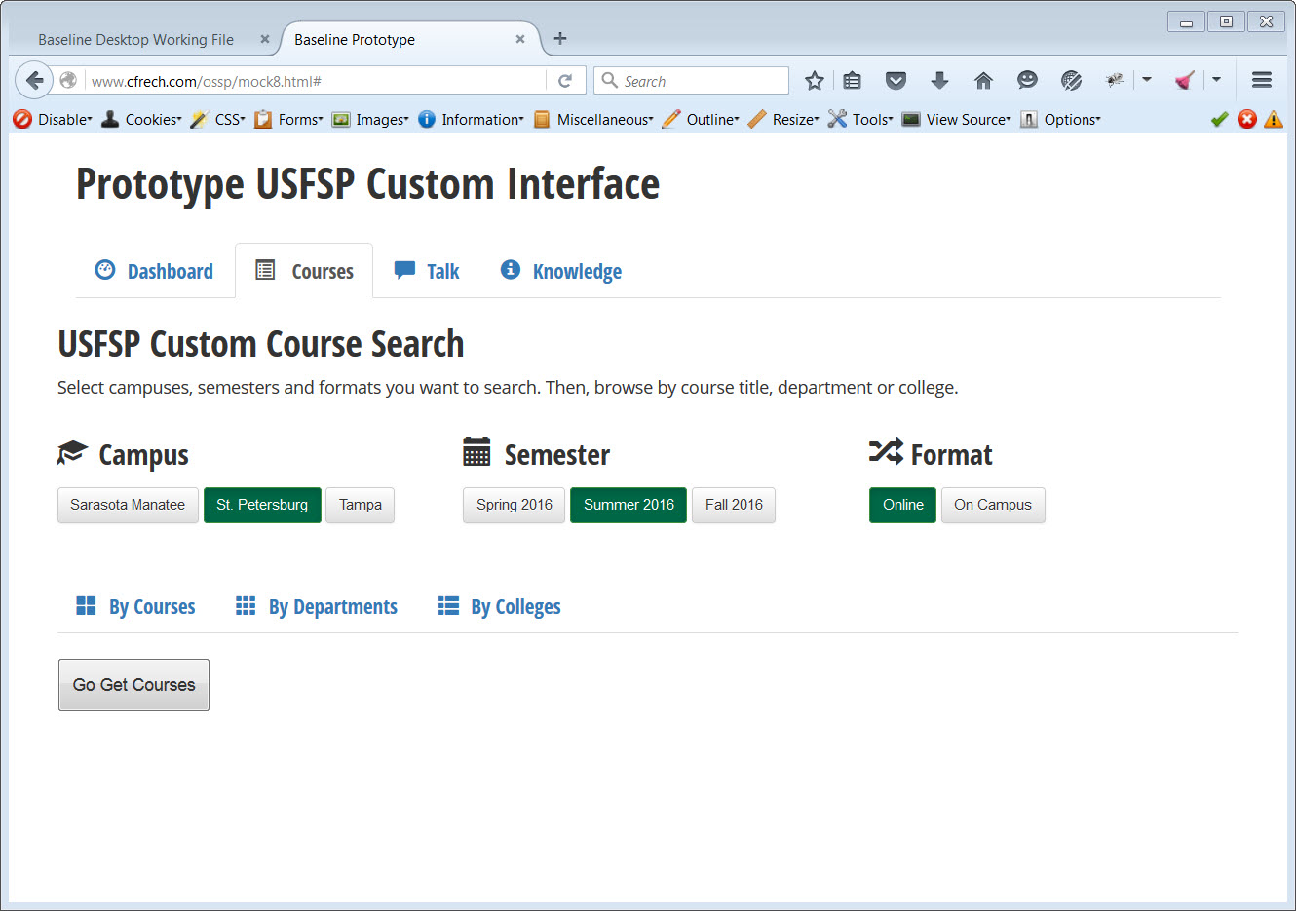

Figure 3. Screenshot of the second tab of the prototype interface.

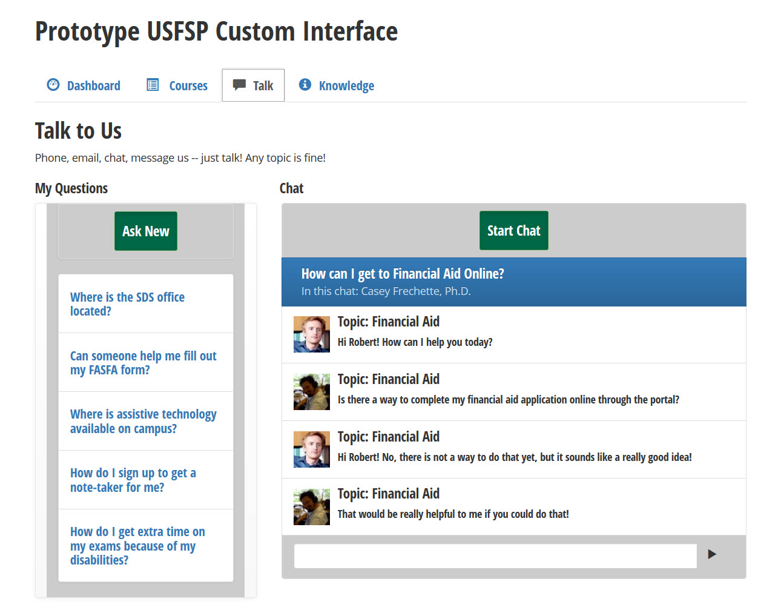

Figure 4. Screenshot of the third tab of the prototype interface. This third tab highlights the chat functionality of the prototype.

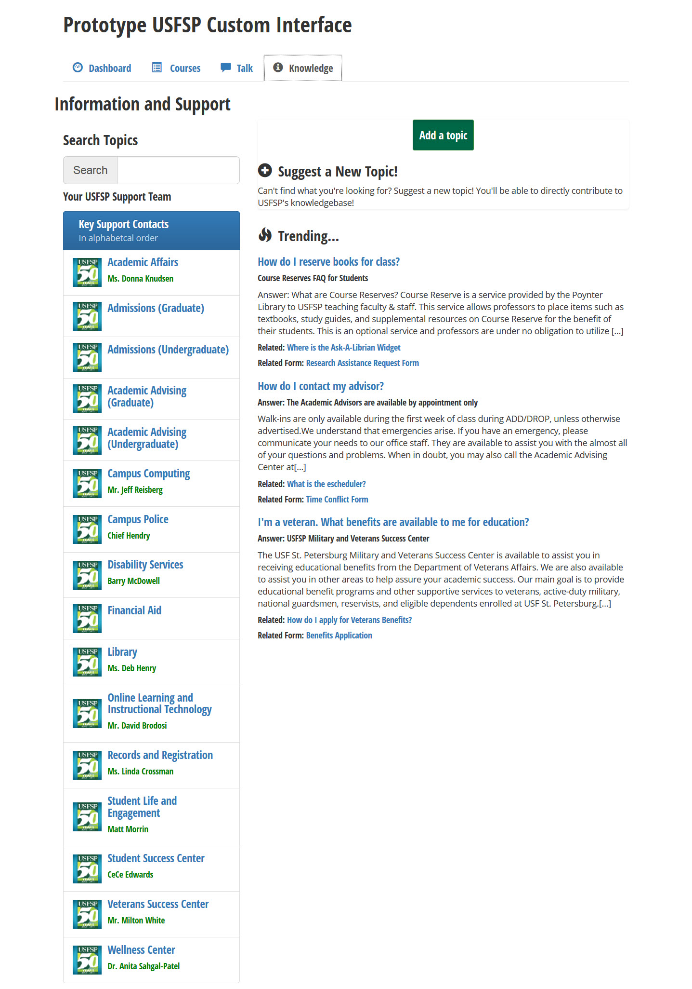

Figure 5. Screenshot of the fourth tab of the prototype interface. This tab highlights the knowledge-base features of the prototype.

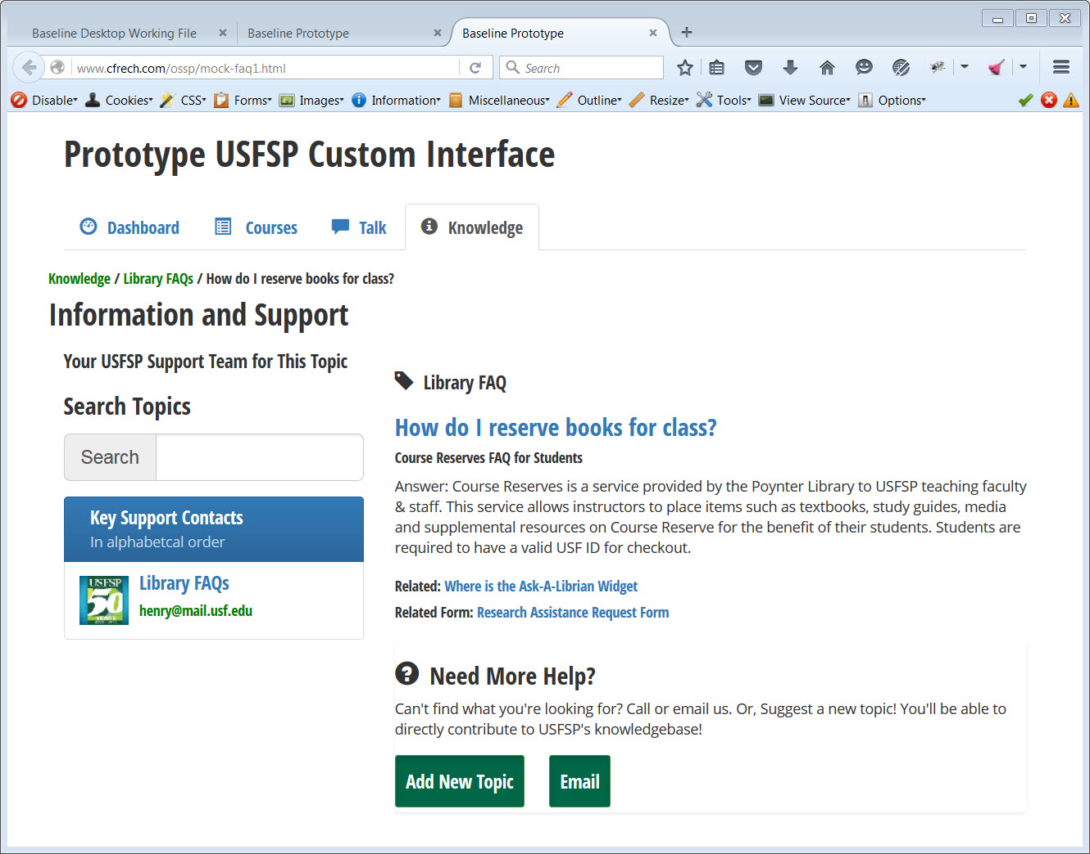

Figure 6. Screenshot of example FAQ generated from clicking on a selected link from the knowledge-base. Note how the menu on the left -- offices associated with the topic-- adjusts to reflect only those offices that are relevant to the topic at hand.

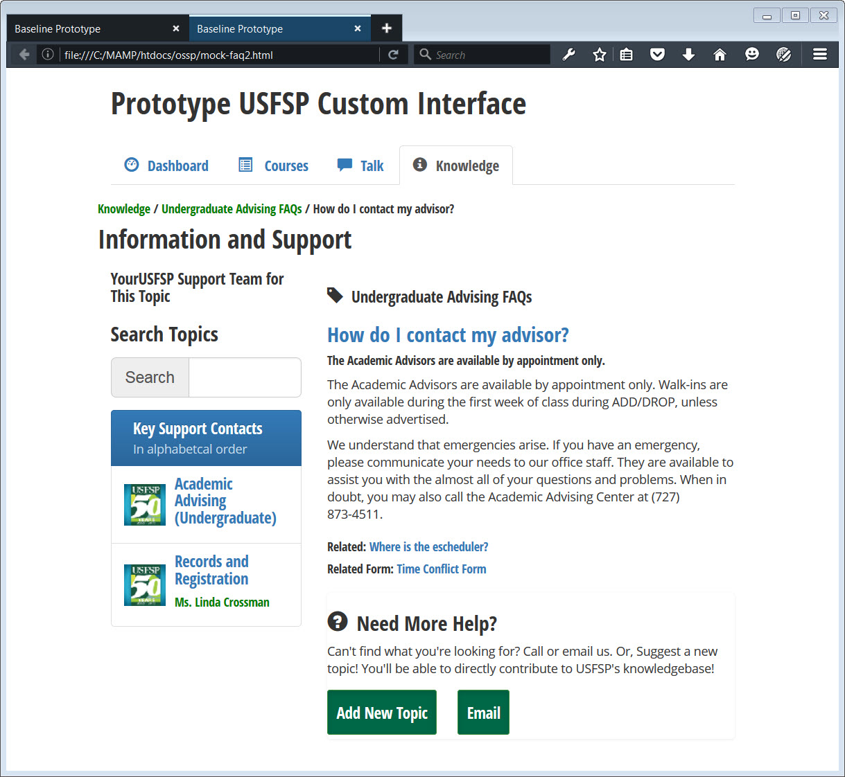

Figure 7. Screenshot of a second FAQ generated from clicking on the knowledge-base screen. Note the customized menu on the left.

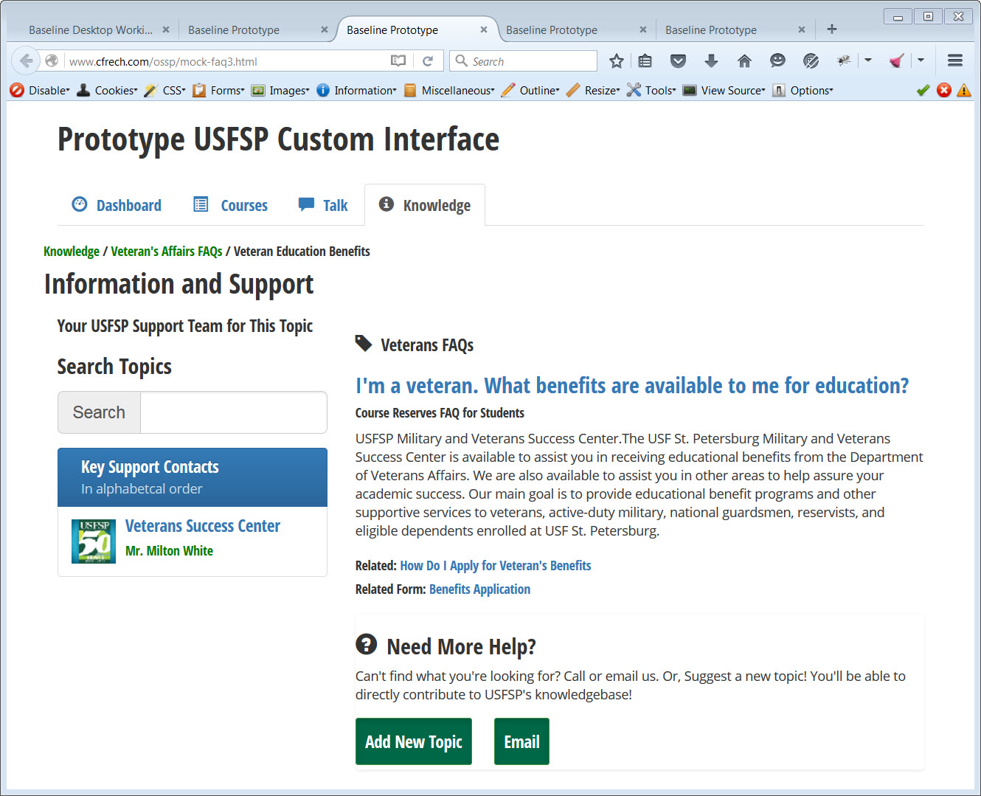

Figure 8. Screenshot of FAQ generated from selection of a knowledge-base article. As in the examples before, note the customized menu on the left in alignment with the topic.